**ETHICAL QUESTIONS/CONCERNS (BA)**

What are some ethical considerations of your product?

* Privacy, allow all users to connect with one another or attend events posted?
* Security (provide login and password). Data misuse.
* Account verification
* User discrimination?

Address any features in your product that could be misused and how you plan to guard against misuse.

* Examples given about loading pictures will need to be addressed. A feature to let other users report inappropriate pictures should be added, as well as possibly a feature that requires the site admin to review and approve the picture for permitting the upload.
* Underage or inappropriate meetups or event creations. A user policy should be implemented stating the rules and requirements for creating an account and/or event. Possibly requiring the user’s UNCC ID #, license # or the ID to be uploaded. This could be in the form of a pop up box or other. Of course with rules stipulating what admin can do with that information if saved in a database.
* Prohibiting the creation of lewd events, by providing a set list of “Topics” to choose from with a submission form to admin if a “new” topic choice is required.
* A way to restrict attendance to the user’s posted events by only allowing those events to be visible to the user’s “accepted” connections. Possibly a “friend request” of some sort after someone shows interest in attending. Only those with verified accounts can choose to RSVP and must be a connection of the hosting user.
* Hosting users should not be able to blatantly prevent other user’s from attending posted events due to race, gender, sexual orientation etc...Thus no data concerning users should be posted for other user’s viewing. Avatar’s and screen names should be utilized.

**STORYBOARD**

Google Sheets Link: https://docs.google.com/presentation/d/1Yc2lH6S2ibsL45OAX3o_cT6T-iu7majWzTuqEz9cZ5c/edit#slide=id.p

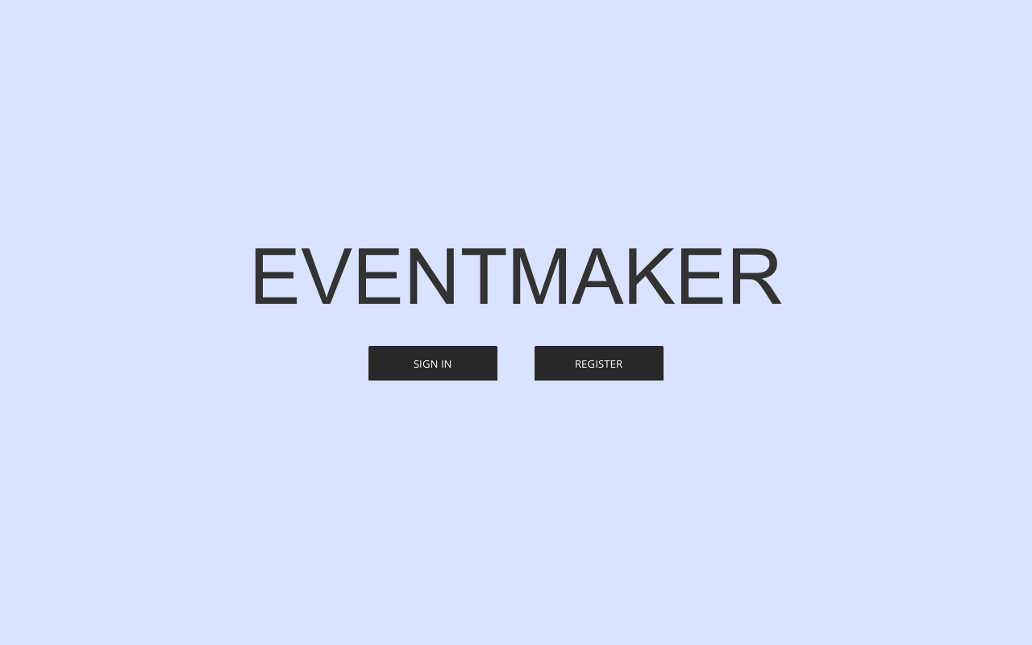

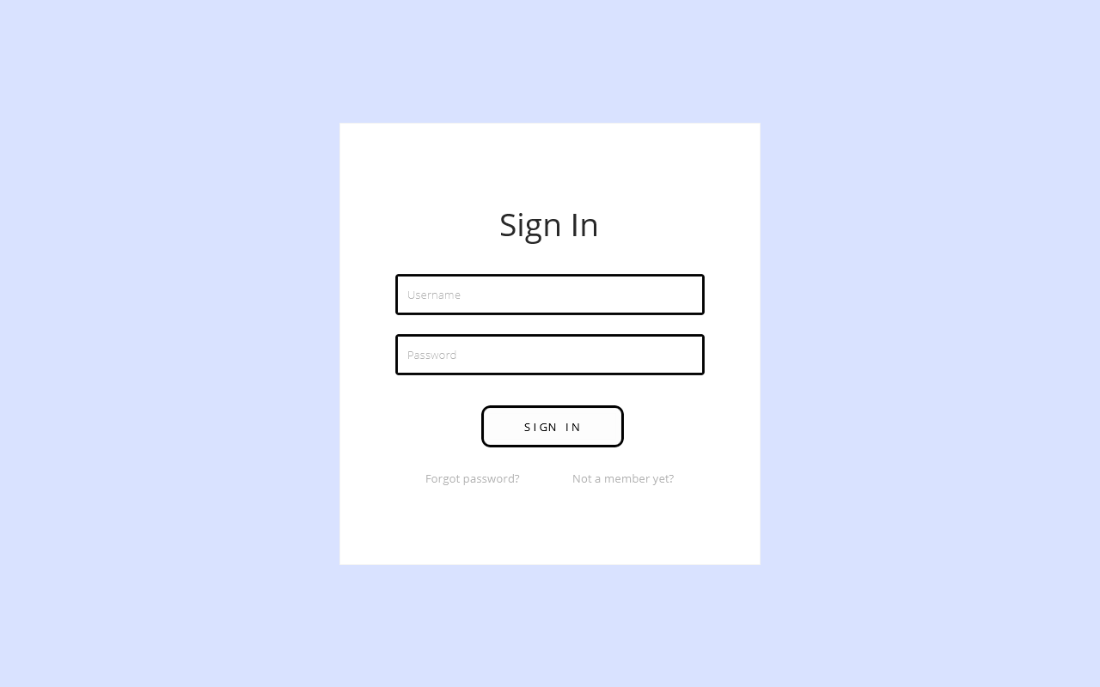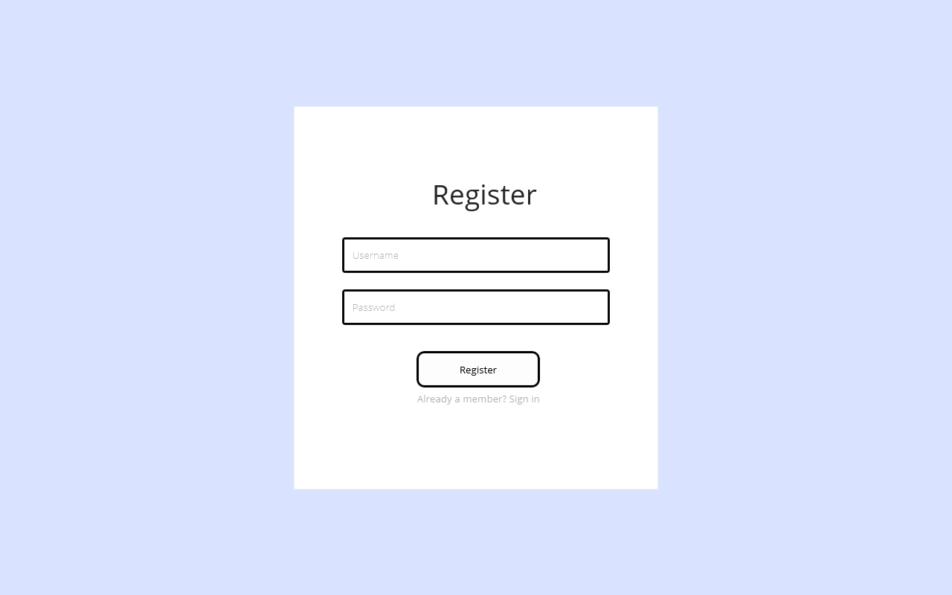

**This is list of pages for Events Management**

